**Satish Pradhan Dnyanasadhana College**



**Project Title:**

Online Project Submission & Management System

**Academic Year:** (2020 – 2021)

**Submitted By: Guided By:**

Akash Santosh Katkar Prof. Pragati Ubale

Roll No. 35

**Problem Statement:**

Recently, due to current covid-19 situation, the whole college institution are facing the problem of teaching. The student aren’t able to gain the information and the exams implement it properly. The student aren’t comfortable about the online exams. As also for the project submission too. The manual submission aren’t possible and can also cause lot of error.

**Abstract:**

Hence to reduce one of the above problems .i.e. the project submissions, we will be implementing this project “Database Management System” where the group/individual could create their project of their choice and also with comfort and ease. Looking from the teachers perspective also, this System Website will also plays a important role as the collections of projects from the subjects could be done easily. In fact the major works of teachers like sorting, ordering, verifying the parts will also be done by the website itself. From the student’s side, the student will be able to create the project of their choice and could easily be changed accordingly also. The project will also be provided with alerts and reminders from the deadlines and update the viewers. In short the benefits will be for both sides and also avoiding the any panic situations. This project aims at digitalizing overall process of project submission.

**Introduction Of System:**

The overall view of the project can be explained as the project submission and the corrections. The website is a management system and the website manage the student’s project in their database. Basically, the website is used to upload the project of a student parts-by-parts classified by the teachers manually. The student actually has to login to the website and create a project of their chosen topic. Then the student is taken to the stages Session where the project will be divided into parts to upload based on the topic. The format for parts to upload is also based on their user’s choice (.i.e. the format for the file upload can be done in multiple ways like pdf format, docx format, etc.). All the stage’s file that the user upload can also be downloaded as we are giving the option for the download options on the same page itself.

After all the stages are uploaded, the project has to upload their overall working project files into a folder compressing it into a zip file. This final project count the main part of the project as it is the vital session of the overall project.

All of the above details are for the student main project upload session. Now considering the Updating and the change of the project, the student is also provided with a whole other page from which the user can alter their project details and the can also delete the project (as for a valid reason). The student can also update and modify their account details accordingly. As the give a motive and an introduction of the existence of the site, we are also providing with “About Us” session .The student account is given with ”Contact” page where the student can access the teacher’s and college faculty contact details for verifying any doubts or queries manually if arises.

As in the teacher session, the account updating and modification is similar as of the student session with all the basic details. The student as for project verification of the student project, the teacher can verify the project thoroughly and can accept and give correction and also can reject the stages/ project. The validation of the project is done stage-wise as each stage validation is far much better than the one time final validation. The teacher can access each individual’s/group’s project file and can reply about the stages and also suggest better solutions also. The student has update and modify the project accordingly on bases of teacher’s report. In this way, there still exists the student-teacher relation while verification. The overall project system is like an interactive session and much more enhanced way of project submission.

In the admin module the system administrator of the college will have the entire rights to remove student and also edit the details of the respective student as well as teacher. The admin can traverse the list of students & teachers based on the ID of the respective student & teacher where only five details will be displayed at a time in a tabular format.

The admin will be able to see the list of students & teachers who have enrolled or are using this website. Through the list of students the admin can also get to known who have submitted the project & the corresponding progress.

The students & teachers can ask any queries related to the functionality of the website through the contact us page. In case of any issues students & teachers can communicate with admin through a chat system & the admin will respond accordingly.

**Objective:**

**The Main Objectives of our Project are:**

* To ease the work load of the teacher and student due to the COVID situation and also due to other difficult.
* To divide the work of the project systematically.
* To avoid the problem of time constraint and submission issues of the project of the students.
* To ease the project corrections and verifications for the teachers.
* Analysis the project submitted in a more comfort manner.
* To reduce errors/mistakes occurring while submitting a manual project.
* More efficiency and consistency.
* Time Management.

**Block Diagram:**

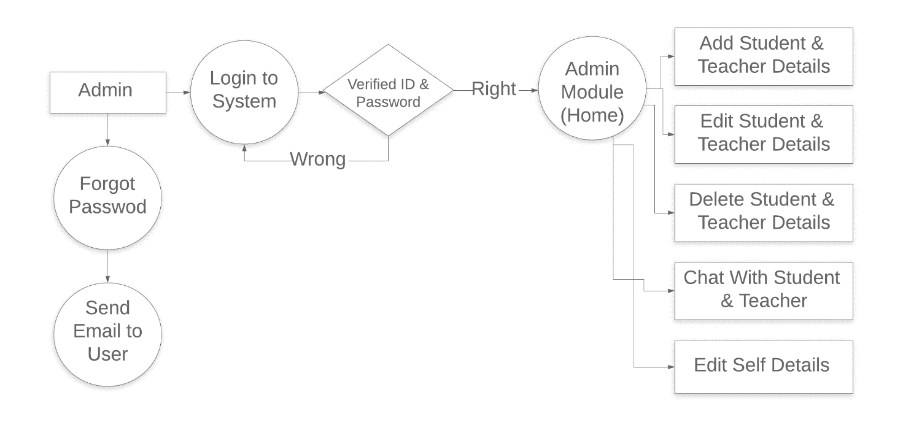

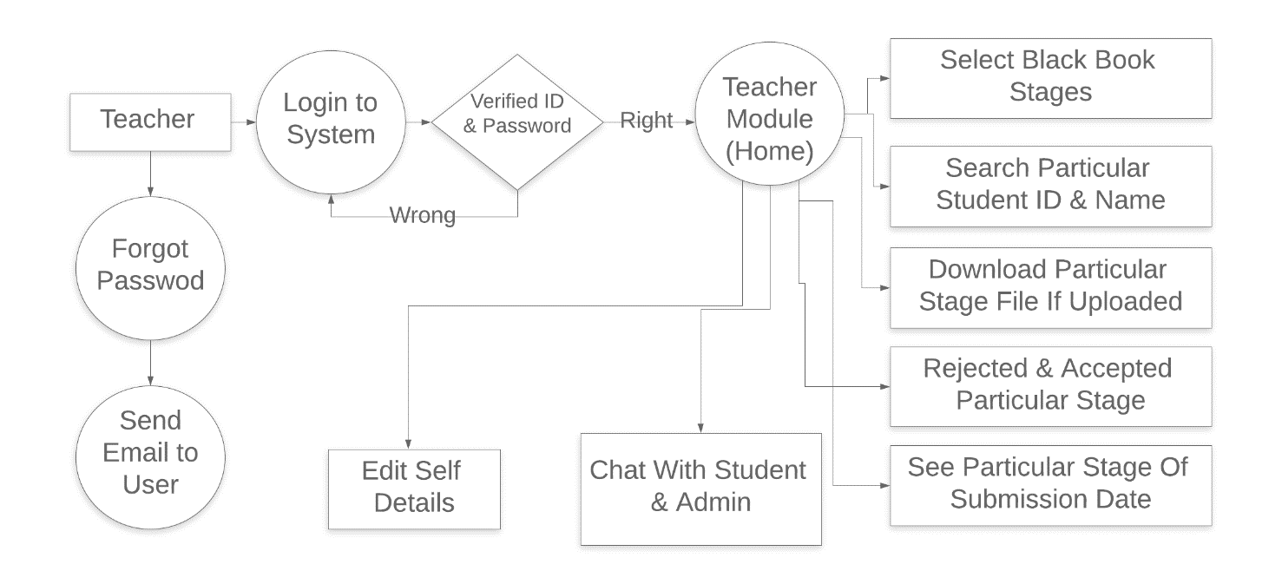

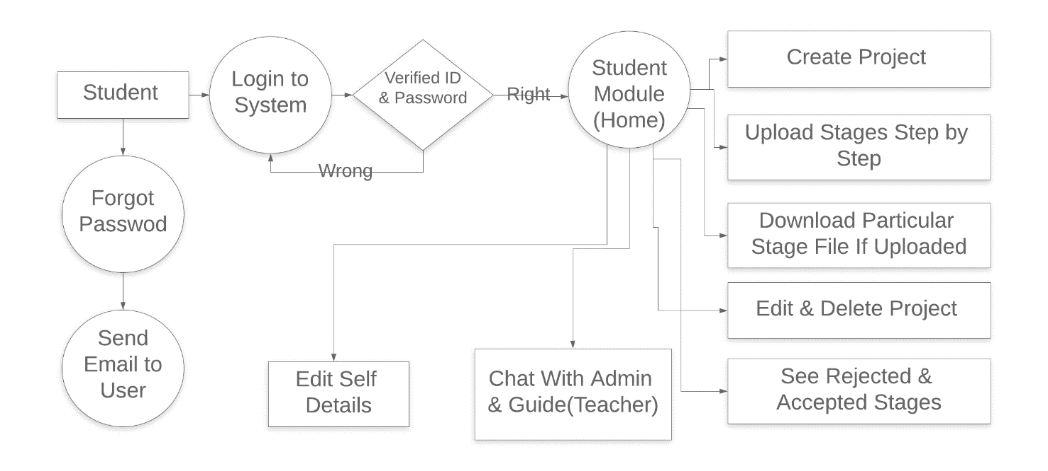

**Working Module:**

**Student Module:**

* In the student module the student can upload the projects and view the progress of the project in stages displayed in view project tab of the website.
* The Students can also upload and download the project uploaded at any point of time.
* The students can view the cause of rejection of a particular stage which will be mentioned by teacher.

**Teacher Module:**

* In the teacher module the teacher can view the projects uploaded by the students and can also download the projects that they like.
* Teacher can reject the contents of a particular stage if they feel that some points were missing to be mentioned.
* Teacher should compulsorily mention the cause of rejection if they reject the project.

**Admin Module:**

* The students & teachers can ask any queries related to the functionality of the website through the contact us page.
* In case of any issues students & teachers can communicate with admin through a chat system & the admin will respond accordingly.
* The admin can edit the values of the particular student & teachers in case any wrong values are detected which may be found after the verification from the college database.

**Advantages:**

* This project has a feedback mechanism though which the student can get the valuable feedback from the teachers about the content of each stages and also the teacher can accept and reject a particular stage and provide their views on why was a particular stage rejected if rejected by teacher.
* The student as well as the teacher can download the uploaded files whenever and wherever needed.
* Hassle free process of resetting password even if the user forgets the password.

**Disadvantages:**

* No usage of AI.

**Hardware & Software Specification:**

**Hardware Requirements**

* Processor – intel i5 or more
* Ram – 4GB or more
* Hard Disk – 1tb

**Software Requirements**

* Operating System – Certified Distribution Of WINDOWS
* Frontend – Visual Code(HTML, CSS, JAVACRIPT, JQUERY, BOOTSTRAP)
* DATABASE(Backend) – MySQL(PHP)

**Future Scope:**

The progress made by each student in their respective project will be displayed in a Graphical/Pictorial format. Integrating AI & Machine Learning to identify the similarities of projects ideas between the students based on words Similarity & Semantics.

**Conclusion:**

The final and main motive while creating this project is to reduce the burden of the students and teachers and increase the efficiency of the project submission of the college student with less errors and mistakes and with more fun and interactive way.